Tab 1

A
PROJECT REPORT
Full-Cycle Hiring Simulation Project
ON
UNDERTAKEN AT
MIT SCHOOL OF DISTANCE EDUCATION
IN PARTIAL FULFILMENT OF
COURSE

HUMAN RESOURCE MANAGEMENT (HRM)
MIT SCHOOL OF DISTANCE EDUCATION, PUNE.
Specialization: Talent Acquisition & HR Technology
SUBMITTED BY
KARLEENA .ANTHONY.WILSON.ANITA
STUDENT REGISTRATION NO.: MIT2022E02953

MIT SCHOOL OF DISTANCE EDUCATION PUNE - 411 038
Project Duration: January 2025 – March 2025

INDEX
 | Section Title | Page No.
1. | Introduction | 3
2. | Project Execution and Tools Used | 4
3. | Screening and Shortlisting Process | 6
4. | Key Learnings and Outcomes | 8
5. | Conclusion | 9

Page 2 – Introduction

The Full-Cycle Hiring Simulation Project was conducted to gain a practical understanding of real-world recruitment operations. This simulation replicated the end-to-end hiring process from drafting job descriptions to shortlisting and coordinating interviews.
The project aimed to develop hands-on skills in:
- Structuring clear job descriptions for multiple roles
- Using Applicant Tracking Systems (ATS) like Zoho Recruit
- Creating scoring mechanisms to streamline screening
- Managing and tracking candidate pipelines effectively
Through this experience, I learned how strategic and data-driven decisions can improve recruitment outcomes and enhance candidate experience.
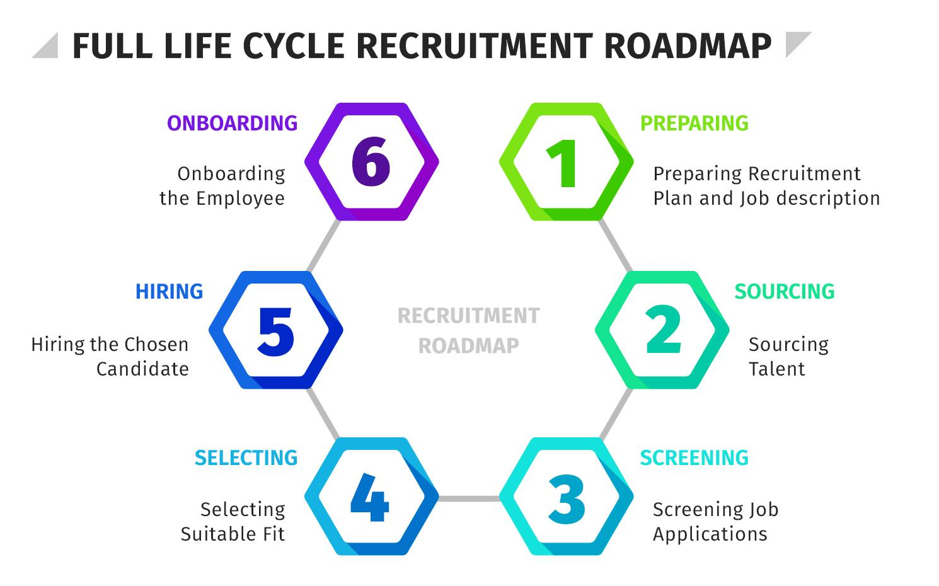

Page 3 – Execution and Tools Used

Project Execution and Tools Used
The simulation involved hiring for three main roles:
- Application Support Executive
- HR Executive
- Helpdesk Coordinator
For each role, a custom job description was created based on industry standards and company needs. These job descriptions highlighted:
- Key Responsibilities
- Required Qualifications
- Skills and Experience
- Location and Shift Timings
Once finalized, roles were posted on simulated job boards. Applications were received and tracked using Zoho Recruit – an ATS platform used in real organizations.
Key activities performed using Zoho Recruit:
- Resume parsing and tagging
- Shortlisting candidates based on filters
- Moving applicants across stages: Applied → Screened → Interviewed
- Sending interview invites and updates
Zoho Recruit candidate pipeline
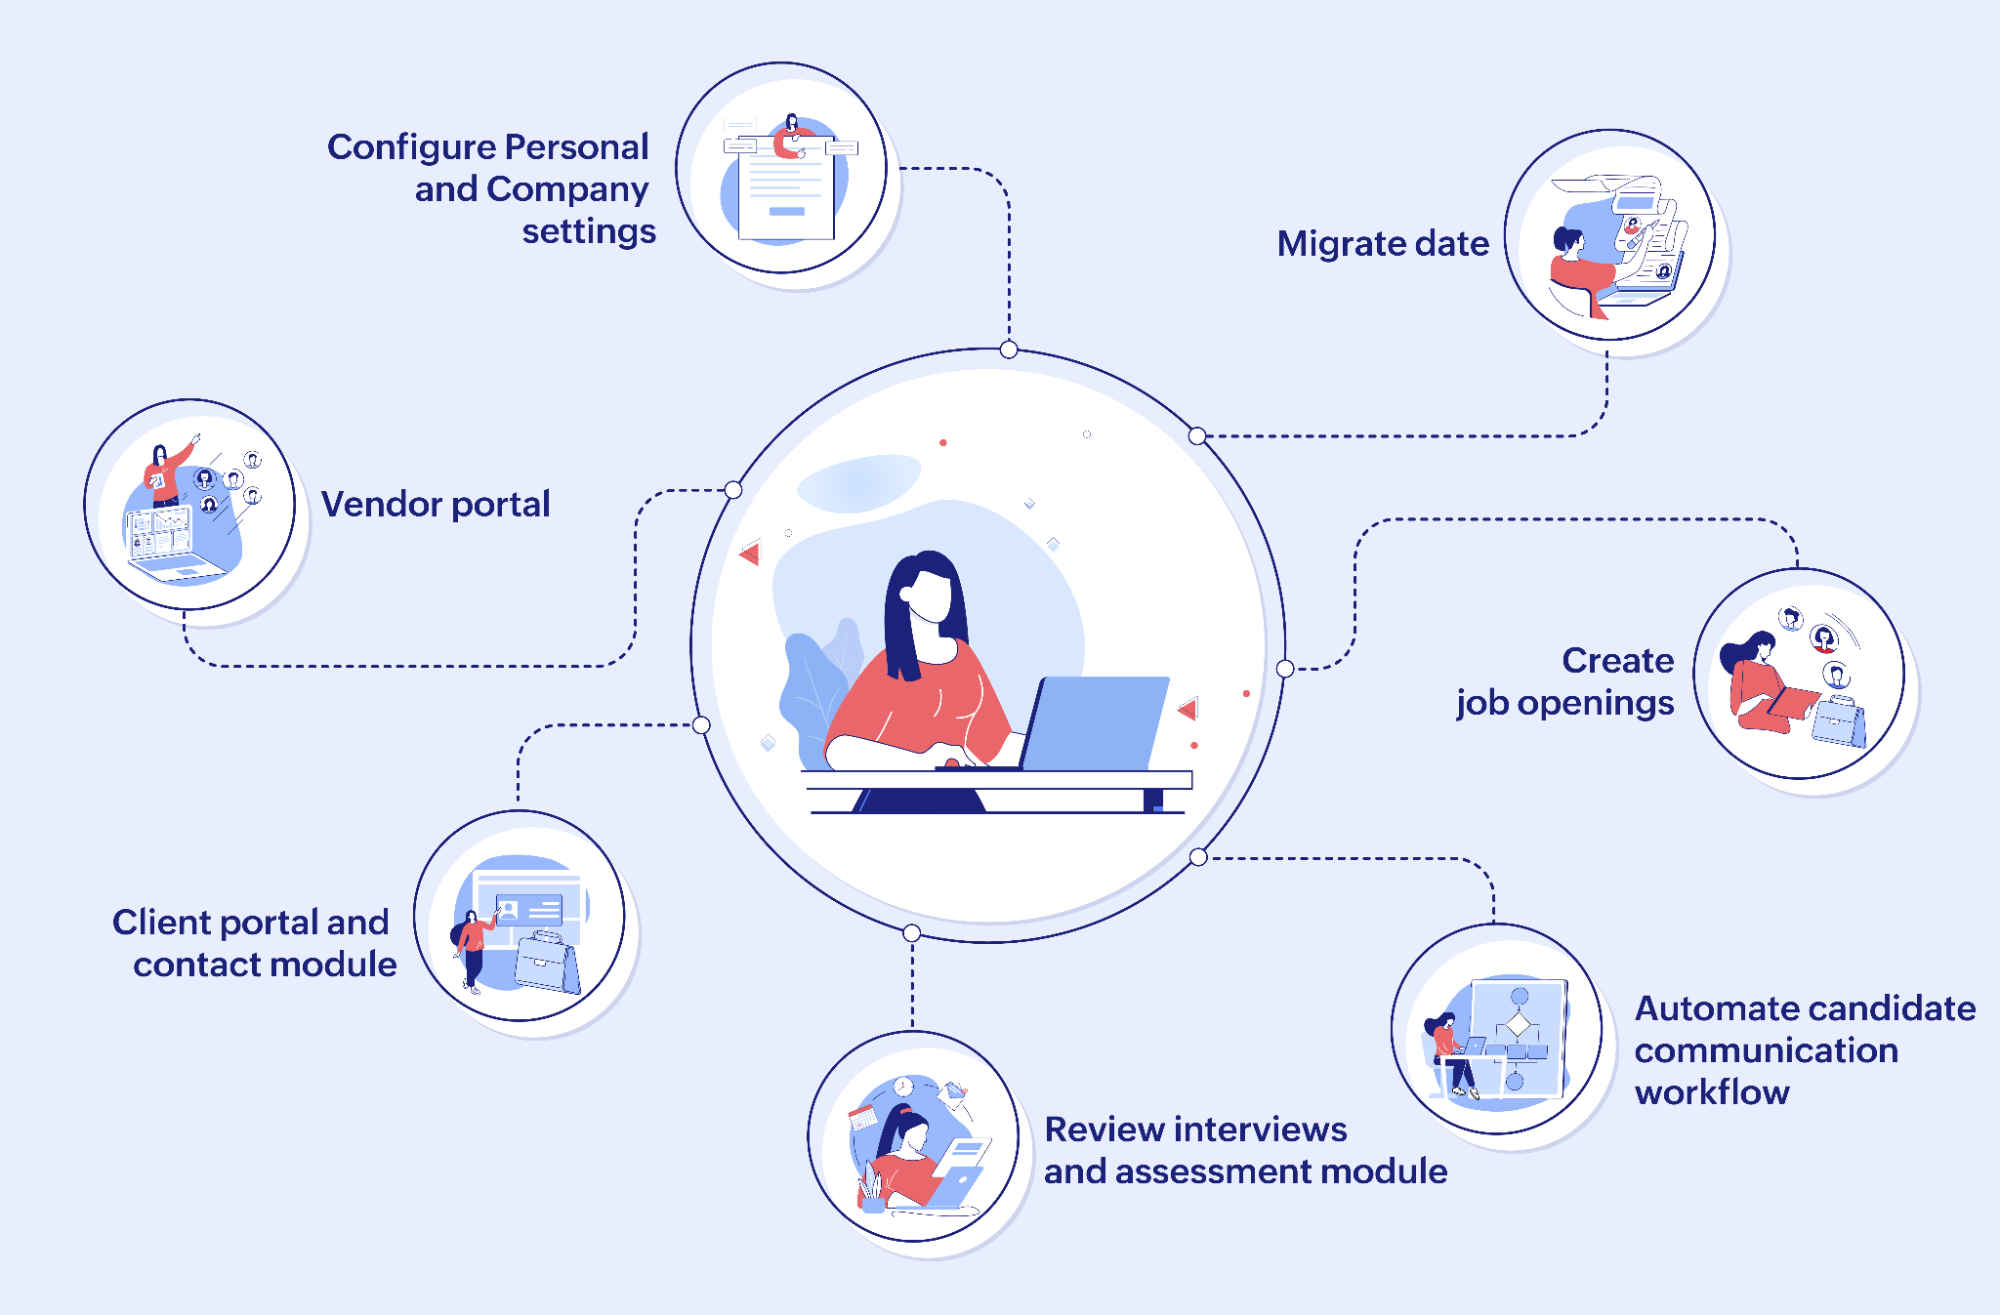
This process simulated real-time HR responsibilities and allowed efficient tracking of candidate progress.

Page 4 – Screening and Shortlisting Process
One of the most valuable outcomes of this project was learning how to improve screening efficiency by 15% using defined criteria.
A structured scoring mechanism was developed based on:
- Educational background (weight: 25%)
- Relevant work experience (25%)
- Communication skills (20%)
- Location proximity (15%)
- Technical and soft skills (15%)
Each application was reviewed and scored accordingly. Candidates who met the minimum cutoff were shortlisted.
Interview coordination involved:
- Scheduling interviews based on mutual availability
- Sending reminder emails/SMS
- Creating interviewer panels
- Documenting feedback after interviews

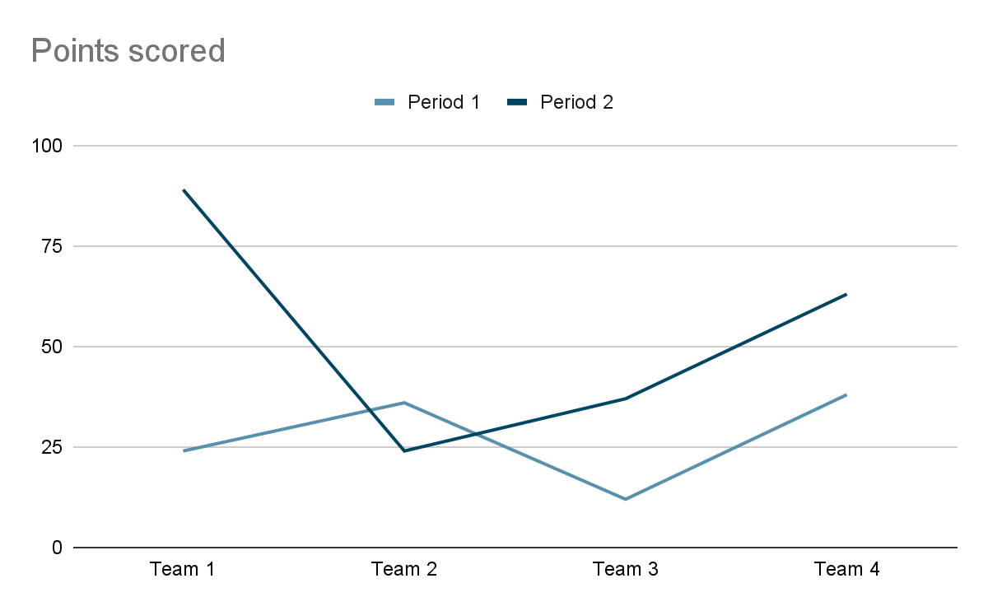

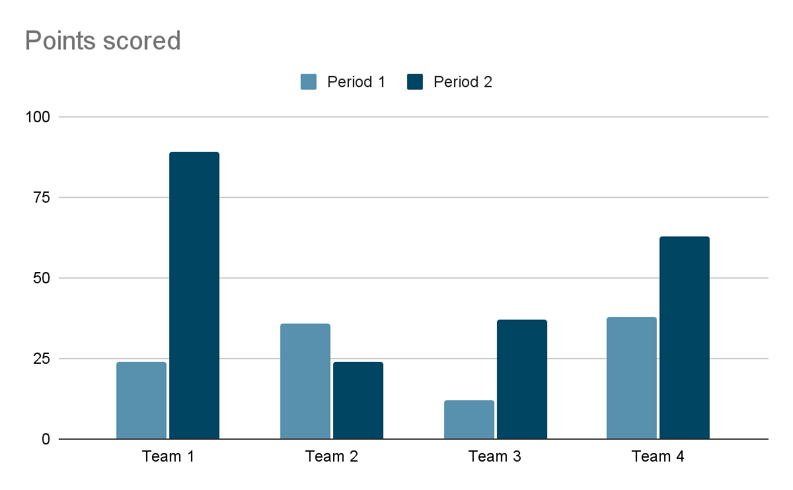

Page 5 – Key Learnings and Outcomes
This project enabled me to:
- Simulate real-time recruitment workflows
- Gain hands-on experience with Zoho Recruit (ATS)
- Improve decision-making using data-backed scoring systems
- Understand communication protocols in talent acquisition

Achievements
✔️ Improved screening speed by 15%
✔️ Managed multiple roles independently
✔️ Practiced end-to-end hiring from sourcing to offer
✔️ Built confidence in using modern HR tech tools
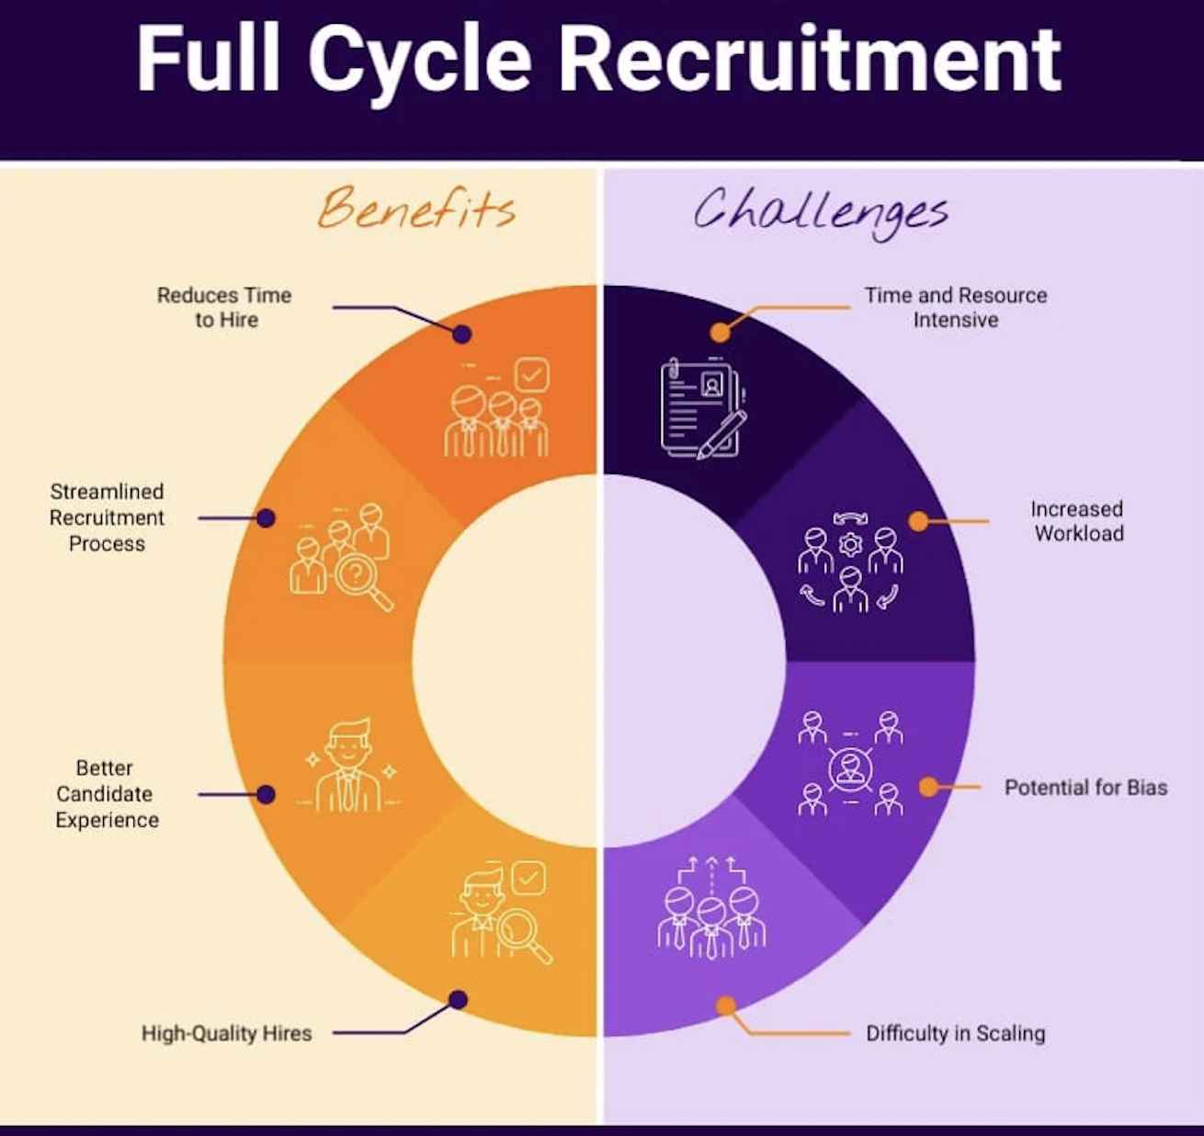

Conclusion
The Full-Cycle Hiring Simulation was a transformative learning experience. It helped bridge the gap between theoretical HR concepts and practical recruitment execution. I now feel well-prepared to handle real-world talent acquisition roles and contribute meaningfully to any organization’s hiring strategy.



Tab 2

